CEEDS_OpenADR_ReferenceEnergyCurveMinMaxOperatingEnvelope Document contextual model

Overview of the model

!# shows the model.

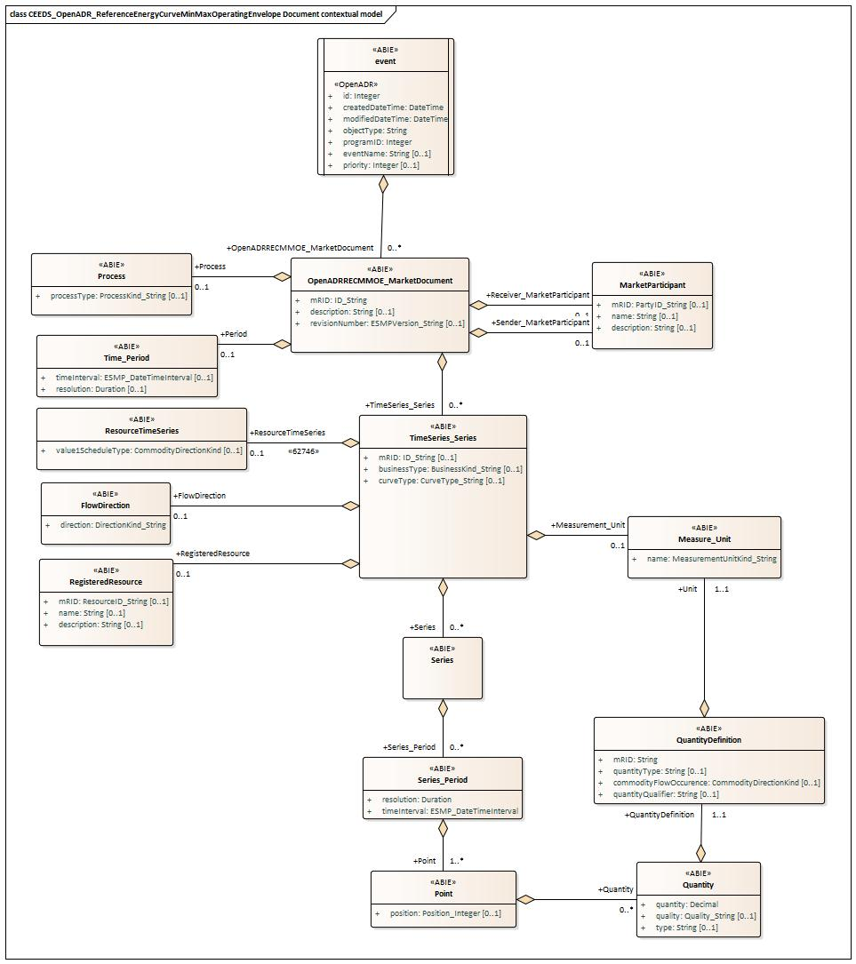

Figure !# - CEEDS_OpenADR_ReferenceEnergyCurveMinMaxOperatingEnvelope Document contextual model

IsBasedOn relationships from the European style market profile

!# shows the traceability dependency of the classes used in this package towards the upper level. Table !# - IsBasedOn dependency

Name Complete IsBasedOn Path

Event CIMProfiles::MarketProfiles::RD_Projects::CEEDS::CEEDS_OpenADR_ReferenceEnergyCurveMinMaxOperatingEnvelope Document::CEEDS_OpenADR_ReferenceEnergyCurveMinMaxOperatingEnvelope Document contextual model::Event

FlowDirection CIMProfiles::MarketProfiles::RD_Projects::CEEDS::CEEDS_OpenADR_ReferenceEnergyCurveMinMaxOperatingEnvelope Document::CEEDS_OpenADR_ReferenceEnergyCurveMinMaxOperatingEnvelope Document contextual model::FlowDirection

MarketParticipant CIMProfiles::MarketProfiles::RD_Projects::CEEDS::CEEDS_OpenADR_ReferenceEnergyCurveMinMaxOperatingEnvelope Document::CEEDS_OpenADR_ReferenceEnergyCurveMinMaxOperatingEnvelope Document contextual model::MarketParticipant

Measure_Unit CIMProfiles::MarketProfiles::RD_Projects::CEEDS::CEEDS_OpenADR_ReferenceEnergyCurveMinMaxOperatingEnvelope Document::CEEDS_OpenADR_ReferenceEnergyCurveMinMaxOperatingEnvelope Document contextual model::Measure_Unit

OpenADRRECMMOE_MarketDocument CIMProfiles::MarketProfiles::RD_Projects::CEEDS::CEEDS_OpenADR_ReferenceEnergyCurveMinMaxOperatingEnvelope Document::CEEDS_OpenADR_ReferenceEnergyCurveMinMaxOperatingEnvelope Document contextual model::OpenADRRECMMOE_MarketDocument

Point CIMProfiles::MarketProfiles::RD_Projects::CEEDS::CEEDS_OpenADR_ReferenceEnergyCurveMinMaxOperatingEnvelope Document::CEEDS_OpenADR_ReferenceEnergyCurveMinMaxOperatingEnvelope Document contextual model::Point

Process CIMProfiles::MarketProfiles::RD_Projects::CEEDS::CEEDS_OpenADR_ReferenceEnergyCurveMinMaxOperatingEnvelope Document::CEEDS_OpenADR_ReferenceEnergyCurveMinMaxOperatingEnvelope Document contextual model::Process

Quantity CIMProfiles::MarketProfiles::RD_Projects::CEEDS::CEEDS_OpenADR_ReferenceEnergyCurveMinMaxOperatingEnvelope Document::CEEDS_OpenADR_ReferenceEnergyCurveMinMaxOperatingEnvelope Document contextual model::Quantity

QuantityDefinition CIMProfiles::MarketProfiles::RD_Projects::CEEDS::CEEDS_OpenADR_ReferenceEnergyCurveMinMaxOperatingEnvelope

Document::CEEDS_OpenADR_ReferenceEnergyCurveMinMaxOperatingEnvelope Document contextual model::QuantityDefinition

RegisteredResource CIMProfiles::MarketProfiles::RD_Projects::CEEDS::CEEDS_OpenADR_ReferenceEnergyCurveMinMaxOperatingEnvelope Document::CEEDS_OpenADR_ReferenceEnergyCurveMinMaxOperatingEnvelope Document contextual model::RegisteredResource

ResourceTimeSeries CIMProfiles::MarketProfiles::RD_Projects::CEEDS::CEEDS_OpenADR_ReferenceEnergyCurveMinMaxOperatingEnvelope Document::CEEDS_OpenADR_ReferenceEnergyCurveMinMaxOperatingEnvelope Document contextual model::ResourceTimeSeries

Series CIMProfiles::MarketProfiles::RD_Projects::CEEDS::CEEDS_OpenADR_ReferenceEnergyCurveMinMaxOperatingEnvelope Document::CEEDS_OpenADR_ReferenceEnergyCurveMinMaxOperatingEnvelope Document contextual model::Series

Series_Period CIMProfiles::MarketProfiles::RD_Projects::CEEDS::CEEDS_OpenADR_ReferenceEnergyCurveMinMaxOperatingEnvelope Document::CEEDS_OpenADR_ReferenceEnergyCurveMinMaxOperatingEnvelope Document contextual model::Series_Period

Time_Period CIMProfiles::MarketProfiles::RD_Projects::CEEDS::CEEDS_OpenADR_ReferenceEnergyCurveMinMaxOperatingEnvelope Document::CEEDS_OpenADR_ReferenceEnergyCurveMinMaxOperatingEnvelope Document contextual model::Time_Period

TimeSeries_Series CIMProfiles::MarketProfiles::RD_Projects::CEEDS::CEEDS_OpenADR_ReferenceEnergyCurveMinMaxOperatingEnvelope Document::CEEDS_OpenADR_ReferenceEnergyCurveMinMaxOperatingEnvelope Document contextual model::TimeSeries_Series

##MXM##

CEEDS_OpenADR_ReferenceEnergyCurveMinMaxOperatingEnveloppe Document assembly model

Overview of the model

!# shows the model.
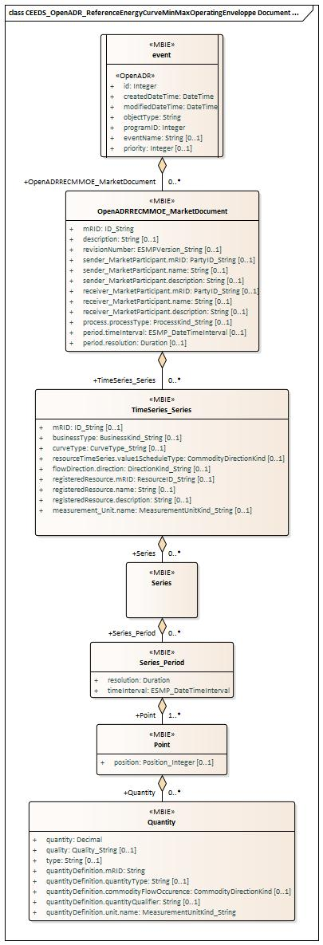

Figure !# - CEEDS_OpenADR_ReferenceEnergyCurveMinMaxOperatingEnveloppe Document assembly model

IsBasedOn relationships from the European style market profile

!# shows the traceability dependency of the classes used in this package towards the upper level. Table !# - IsBasedOn dependency

Name Complete IsBasedOn Path

Event CIMProfiles::MarketProfiles::RD_Projects::CEEDS::CEEDS_OpenADR_ReferenceEnergyCurveMinMaxOperatingEnvelope

Document::CEEDS_OpenADR_ReferenceEnergyCurveMinMaxOperatingEnveloppe Document assembly model::Event OpenADRRECMMOE_MarketDocument CIMProfiles::MarketProfiles::RD_Projects::CEEDS::CEEDS_OpenADR_ReferenceEnergyCurveMinMaxOperatingEnvelope
Document::CEEDS_OpenADR_ReferenceEnergyCurveMinMaxOperatingEnveloppe Document assembly
model::OpenADRRECMMOE_MarketDocument

Point CIMProfiles::MarketProfiles::RD_Projects::CEEDS::CEEDS_OpenADR_ReferenceEnergyCurveMinMaxOperatingEnvelope Document::CEEDS_OpenADR_ReferenceEnergyCurveMinMaxOperatingEnveloppe Document assembly model::Point

Quantity CIMProfiles::MarketProfiles::RD_Projects::CEEDS::CEEDS_OpenADR_ReferenceEnergyCurveMinMaxOperatingEnvelope Document::CEEDS_OpenADR_ReferenceEnergyCurveMinMaxOperatingEnveloppe Document assembly model::Quantity

Series CIMProfiles::MarketProfiles::RD_Projects::CEEDS::CEEDS_OpenADR_ReferenceEnergyCurveMinMaxOperatingEnvelope Document::CEEDS_OpenADR_ReferenceEnergyCurveMinMaxOperatingEnveloppe Document assembly model::Series

Series_Period CIMProfiles::MarketProfiles::RD_Projects::CEEDS::CEEDS_OpenADR_ReferenceEnergyCurveMinMaxOperatingEnvelope Document::CEEDS_OpenADR_ReferenceEnergyCurveMinMaxOperatingEnveloppe Document assembly model::Series_Period

TimeSeries_Series CIMProfiles::MarketProfiles::RD_Projects::CEEDS::CEEDS_OpenADR_ReferenceEnergyCurveMinMaxOperatingEnvelope Document::CEEDS_OpenADR_ReferenceEnergyCurveMinMaxOperatingEnveloppe Document assembly model::TimeSeries_Series

##MXM##

Detailed CEEDS_OpenADR_ReferenceEnergyCurveMinMaxOperatingEnveloppe Document assembly model

Event root class

!# shows all attributes of Event.

Table !# - Attributes of CEEDS_OpenADR_ReferenceEnergyCurveMinMaxOperatingEnveloppe Document assembly model::Event Order mult. Attribute name / Attribute type Description

- [1..1] id Identification of the event

Integer

- [1..1] createdDateTime Date and time this event has been created

DateTime

- [1..1] modifiedDateTime Date and time this event has been modified

DateTime

- [1..1] objectType Used as discriminator.

String

- [1..1] programID ID attribute of the program object the event is associated with.

Integer

- [0..1] eventName User defined string for use in debugging or User Interface.

String

- [0..1] priority Relative priority of event. A lower number is a higher priority.

Integer

##MXM##

!# shows all association ends of Event with other classes.

Table !# - Association ends of CEEDS_OpenADR_ReferenceEnergyCurveMinMaxOperatingEnveloppe Document assembly model::Event with other classes Order mult. Class name / Role Description

- [1..*] OpenADRRECMMOE_MarketDocument
Association Based On :
OpenADRRECMMOE_MarketDocument CEEDS_OpenADR_ReferenceEnergyCurveMinMaxOperatingEnvelope Document contextual
model::Event.[]

CEEDS_OpenADR_ReferenceEnergyCurveMinMaxOperatingEnvelope Document contextual model::OpenADRRECMMOE_MarketDocument.OpenADRRECMMOE_MarketDocument[1..*]

##MXM##

OpenADRRECMMOE_MarketDocument

An electronic document containing the information necessary to satisfy the requirements of a given business process.

!# shows all attributes of OpenADRRECMMOE_MarketDocument.

Table !# - Attributes of CEEDS_OpenADR_ReferenceEnergyCurveMinMaxOperatingEnveloppe Document assembly model::OpenADRRECMMOE_MarketDocument

Order mult. Attribute name / Attribute type Description

0 [1..1] mRID The unique identification of the document being exchanged within a business process flow.

ID_String In the ESMP context, the "model authority" is defined as a party (originator of the exchange) that provides an identification in the context of a business exchange such as document identification, ...

Master resource identifier issued by a model authority. The mRID is globally unique within an exchange context.
Global uniqueness is easily achieved by using a UUID for the mRID. It is strongly recommended to do this. For CIMXML data files in RDF syntax, the mRID is mapped to rdf:ID or rdf:about attributes that identify CIM

object elements.

- [0..1] description The description is a free human readable text describing or naming the object. It may be non unique and may
not correlate to a naming hierarchy.
String

- [0..1] revisionNumber The identification of the version that distinguishes one evolution of a document from another.

ESMPVersion_String

- [0..1] sender_MarketParticipant.mRID The identification of a party in the energy market.

PartyID_String In the ESMP context, the "model authority" is defined as an authorized issuing office that provides an agreed identification coding scheme for market participant, domain, measurement point, resources (generator, lines, substations, etc.) identification.

Master resource identifier issued by a model authority. The mRID is globally unique within an exchange context.
Global uniqueness is easily achieved by using a UUID for the mRID. It is strongly recommended to do this. For CIMXML data files in RDF syntax, the mRID is mapped to rdf:ID or rdf:about attributes that identify CIM object elements.

- [0..1] sender_MarketParticipant.name The name is any free human readable and possibly non unique text naming the object.

String

- [0..1] sender_MarketParticipant.description The description is a free human readable text describing or naming the object. It may be non unique and may
not correlate to a naming hierarchy.
String

- [0..1] receiver_MarketParticipant.mRID The identification of a party in the energy market.

PartyID_String In the ESMP context, the "model authority" is defined as an authorized issuing office that provides an agreed identification coding scheme for market participant, domain, measurement point, resources (generator, lines, substations, etc.) identification.

Master resource identifier issued by a model authority. The mRID is globally unique within an exchange context.
Global uniqueness is easily achieved by using a UUID for the mRID. It is strongly recommended to do this. For CIMXML data files in RDF syntax, the mRID is mapped to rdf:ID or rdf:about attributes that identify CIM object elements.

- [0..1] receiver_MarketParticipant.name The name is any free human readable and possibly non unique text naming the object.

String

- [0..1] receiver_MarketParticipant.description The description is a free human readable text describing or naming the object. It may be non unique and may
not correlate to a naming hierarchy.
String

- [0..1] process.processType The identification of the nature of process that the document addresses.
--- The Process associated with an electronic document header that is valid for the whole document.
ProcessKind_String

- [0..1] period.timeInterval The start and end date and time for a given interval.

ESMP_DateTimeInterval --- The time interval that is associated with an electronic document and which is valid for the whole document.

- [0..1] period.resolution The number of units of time that compose an individual step within a period.

Duration --- The time interval that is associated with an electronic document and which is valid for the whole document.
##MXM##

!# shows all association ends of OpenADRRECMMOE_MarketDocument with other classes.

Table !# - Association ends of CEEDS_OpenADR_ReferenceEnergyCurveMinMaxOperatingEnveloppe Document assembly model::OpenADRRECMMOE_MarketDocument with other classes

Order mult. Class name / Role Description

- [0..*] TimeSeries_Series The time series that is associated with an electronic document. Association Based On :
TimeSeries_Series CEEDS_OpenADR_ReferenceEnergyCurveMinMaxOperatingEnvelope Document contextual
model::OpenADRRECMMOE_MarketDocument.[]

CEEDS_OpenADR_ReferenceEnergyCurveMinMaxOperatingEnvelope Document contextual model::TimeSeries_Series.TimeSeries_Series[0..*]

##MXM##

Point

The identification of the values being addressed within a specific interval of time.

!# shows all attributes of Point.

Table !# - Attributes of CEEDS_OpenADR_ReferenceEnergyCurveMinMaxOperatingEnveloppe Document assembly model::Point Order mult. Attribute name / Attribute type Description

0 [0..1] position A sequential value representing the relative position within a given time interval.

Position_Integer

##MXM##

!# shows all association ends of Point with other classes.

Table !# - Association ends of CEEDS_OpenADR_ReferenceEnergyCurveMinMaxOperatingEnveloppe Document assembly model::Point with other classes Order mult. Class name / Description

Role
1 [0..*] Quantity The Quantity information associated with a given Point.
Association Based On :
Quantity CEEDS_OpenADR_ReferenceEnergyCurveMinMaxOperatingEnvelope Document contextual model::Point.[]

CEEDS_OpenADR_ReferenceEnergyCurveMinMaxOperatingEnvelope Document contextual model::Quantity.Quantity[0..*]

##MXM##

Quantity

Description of quantities needed in the data exchange.

The type of the quantity is described either by the role of the association or the quantityType attribute. The quality attribute provides the information about the quality of the quantity (measured, estimated, etc.).
!# shows all attributes of Quantity.

Table !# - Attributes of CEEDS_OpenADR_ReferenceEnergyCurveMinMaxOperatingEnveloppe Document assembly model::Quantity
Order mult. Attribute name / Attribute type Description
0 [1..1] quantity The quantity value.
The association role provides the information about what is expressed.
Decimal
1 [0..1] quality The description of the quality of the quantity.

Quality_String
2 [0..1] type The description of the type of the quantity.

String
3 [1..1] quantityDefinition.mRID Master resource identifier issued by a model authority. The mRID is unique within an exchange context.
Global uniqueness is easily achieved by using a UUID, as specified in IETF RFC 4122, for the mRID.
String The use of UUID is strongly recommended.
For CIMXML data files in RDF syntax conforming to IEC 61970-552, the mRID is mapped to rdf:ID or rdf:about attributes that identify CIM object elements.
4 [0..1] quantityDefinition.quantityType Describes an observable property that can be measured and quantified numerically. Electricity related
examples are ActivePower, ReactivePower, ActiveEnergy, ReactiveEnergy.
String
5 [0..1] quantityDefinition.commodityFlowOccurence The direction of flow, such as that of water or electricity, for the quantity. Quantities can be for
measurements, or expected future values, e.g. forecast, schedule, instruction.
CommodityDirectionKind

- [0..1] quantityDefinition.quantityQualifier Role or characteristic of the quantity type. For example: average measured value, minimum measured
value, maximum measured value, forecast expected value, forecast lower bound, forecast upper bound,
String lower operational limit, upper operational limit.

- [1..1] quantityDefinition.unit.name The identification of the formal code for a measurement unit (UN/ECE Recommendation 20).

MeasurementUnitKind_String

##MXM##

Series

A set of similar physical or conceptual objects defined for the same period or point of time.

!# shows all association ends of Series with other classes.

Table !# - Association ends of CEEDS_OpenADR_ReferenceEnergyCurveMinMaxOperatingEnveloppe Document assembly model::Series with other classes Order mult. Class name / Description
Role

0 [0..*] Series_Period The time interval and resolution for a period associated with a TimeSeries.
Association Based On :
Series_Period CEEDS_OpenADR_ReferenceEnergyCurveMinMaxOperatingEnvelope Document contextual model::Series.[]

CEEDS_OpenADR_ReferenceEnergyCurveMinMaxOperatingEnvelope Document contextual model::Series_Period.Series_Period[0..*]

##MXM##

Series_Period

The identification of the period of time corresponding to a given time interval and resolution.

!# shows all attributes of Series_Period.

Table !# - Attributes of CEEDS_OpenADR_ReferenceEnergyCurveMinMaxOperatingEnveloppe Document assembly model::Series_Period Order mult. Attribute name / Attribute type Description

- [1..1] resolution The definition of the number of units of time that compose an individual step within a period.

Duration

- [1..1] timeInterval The start and end time of the period.

ESMP_DateTimeInterval

##MXM##

!# shows all association ends of Series_Period with other classes.

Table !# - Association ends of CEEDS_OpenADR_ReferenceEnergyCurveMinMaxOperatingEnveloppe Document assembly model::Series_Period with other classes

Order mult. Class name / Role Description

2 [1..*] Point The Point information associated with a given Series_Period.within a TimeSeries.
Association Based On :
Point CEEDS_OpenADR_ReferenceEnergyCurveMinMaxOperatingEnvelope Document contextual model::Series_Period.[]

CEEDS_OpenADR_ReferenceEnergyCurveMinMaxOperatingEnvelope Document contextual model::Point.Point[1..*]

##MXM##

TimeSeries_Series

A set of similar physical or conceptual objects defined for the same period or point of time.

!# shows all attributes of TimeSeries_Series.

Table !# - Attributes of CEEDS_OpenADR_ReferenceEnergyCurveMinMaxOperatingEnveloppe Document assembly model::TimeSeries_Series
Order mult. Attribute name / Attribute type |  | Description
0 | [0..1] mRID  ID_String | A unique identification of the time series.  In the ESMP context, the "model authority" is defined as a party (originator of the exchange) that provides a unique identification in the context of a business exchange such as time series identification, bid identification, ...  Master resource identifier issued by a model authority. The mRID is globally unique within an exchange context.  Global uniqueness is easily achieved by using a UUID for the mRID. It is strongly recommended to do this. For CIMXML data files in RDF syntax, the mRID is mapped to rdf:ID or rdf:about attributes that identify  CIM object elements.
1 | [0..1] businessType  BusinessKind_String | The identification of the nature of the time series.
2 | [0..1] curveType  CurveType_String | The identification of the coded representation of the type of curve being described.

- [0..1] resourceTimeSeries.value1ScheduleType Value1ScheduleType documents two key features for a specific resource operating mode: (a) the energy
flow convention for a positive number as either production or consumption of service and (b) the sense of CommodityDirectionKind how the resource is planned to be used or was used as either a target or setpoint or as a relative change
to a defined level.

- [0..1] flowDirection.direction The coded identification of the direction of energy flow.

DirectionKind_String --- The flow direction associated with a TimeSeries.

- [0..1] registeredResource.mRID The unique identification of a resource.

ResourceID_String In the ESMP context, the "model authority" is defined as an authorized issuing office that provides an agreed identification coding scheme for market participant, domain, measurement point, resources (generator, lines, substations, etc.) identification.

Master resource identifier issued by a model authority. The mRID is globally unique within an exchange context.
Global uniqueness is easily achieved by using a UUID for the mRID. It is strongly recommended to do this. For CIMXML data files in RDF syntax, the mRID is mapped to rdf:ID or rdf:about attributes that identify CIM object elements.
--- The identification of a resource associated with a TimeSeries.

- [0..1] registeredResource.name The name is any free human readable and possibly non unique text naming the object.
--- The identification of a resource associated with a TimeSeries.
String

- [0..1] registeredResource.description The description is a free human readable text describing or naming the object. It may be non unique and
may not correlate to a naming hierarchy.
String --- The identification of a resource associated with a TimeSeries.

- [0..1] measurement_Unit.name The identification of the formal code for a measurement unit (UN/ECE Recommendation 20).
--- The unit of measure associated with the quantities in a TimeSeries.
MeasurementUnitKind_String

##MXM##

!# shows all association ends of TimeSeries_Series with other classes.

Table !# - Association ends of CEEDS_OpenADR_ReferenceEnergyCurveMinMaxOperatingEnveloppe Document assembly model::TimeSeries_Series with other classes

Order mult. Class name / Role Description 9 [0..*] Series
Association Based On :
Series CEEDS_OpenADR_ReferenceEnergyCurveMinMaxOperatingEnvelope Document contextual model::TimeSeries_Series.[]

CEEDS_OpenADR_ReferenceEnergyCurveMinMaxOperatingEnvelope Document contextual model::Series.Series[0..*]

##MXM##

Datatypes
The list of datatypes used for the CEEDS_OpenADR_ReferenceEnergyCurveMinMaxOperatingEnveloppe Document assembly model is as follows: ESMP_DateTimeInterval compound
BusinessKind_String datatype, codelist BusinessTypeList CurveType_String datatype, codelist CurveTypeList DirectionKind_String datatype, codelist DirectionTypeList ESMPVersion_String datatype
ID_String datatype
MeasurementUnitKind_String datatype, codelist UnitOfMeasureTypeList PartyID_String datatype, codelist CodingSchemeTypeList Position_Integer datatype
ProcessKind_String datatype, codelist ProcessTypeList Quality_String datatype, codelist QualityTypeList ResourceID_String datatype, codelist CodingSchemeTypeList YMDHM_DateTime datatype

